Assignment 3

I have used Docker Windows desktop app with WlS2 with linux terminal .   
Having issue with Dual OS setup with Linux. But I have used Linux Wls2 terminal to perform this activity.

1. **Check Docker version**

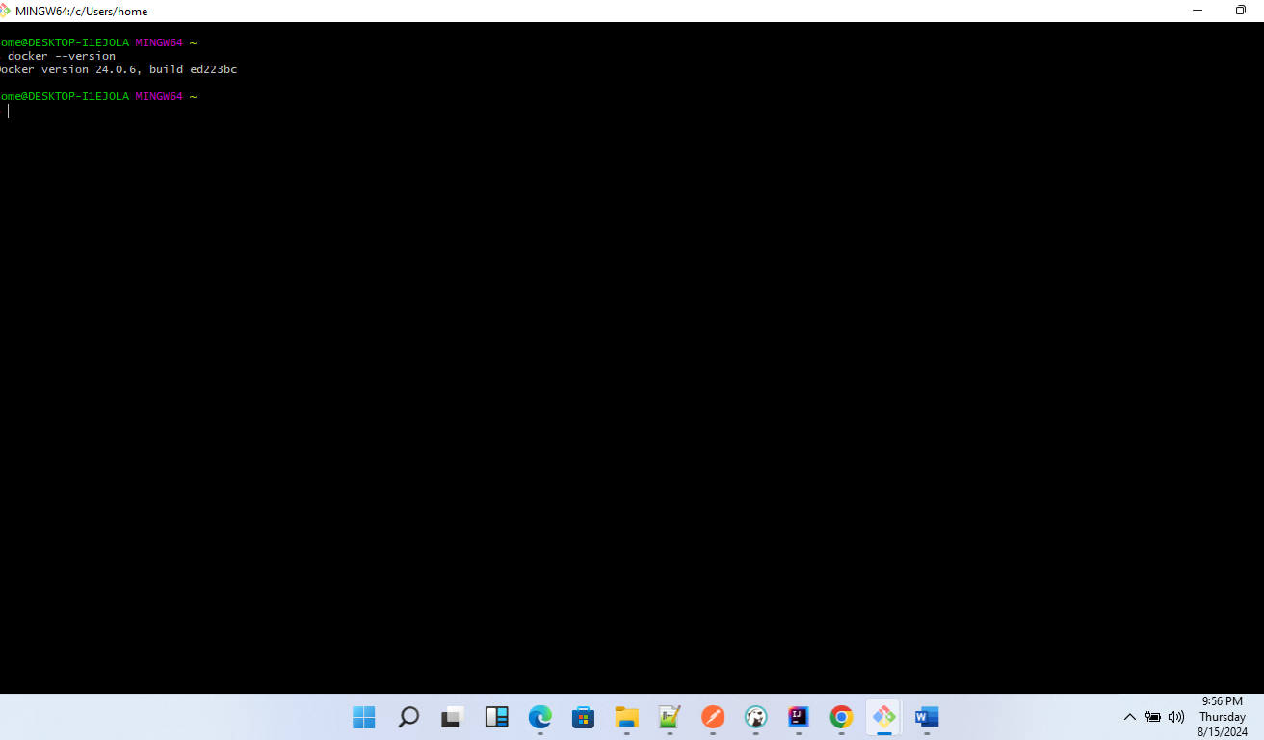

1. Run docker Hello world

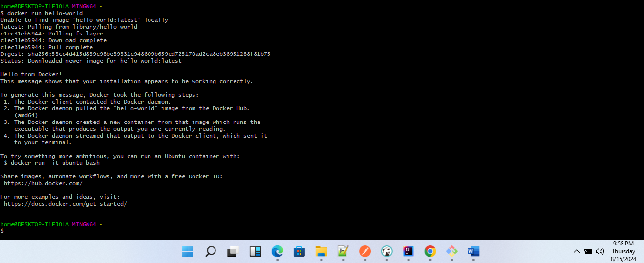

1. List docker images

